Lab: Combinatorial Algorithms

This document defines the **in-class exercises** (lab) for the ["Algortihms" course @ Software University](https://softuni.bg/opencourses/algorithms).

# Part I - Permutations

## Permutations without Repetitions

Given a set of elements, find all permutations without repetitions.

### Examples

|  |  |
| --- | --- |
| **Input** | **Output** |
| A B C | A B C  A C B  B A C  B C A  C B A  C A B |

## Permutations with Repetitions

Given a multi-set of elements, find all permutations.

### Examples

|  |  |
| --- | --- |
| **Input** | **Output** |
| A B B | A B B  B A B  B B A |

# Part II - Variations

## Variations without Repetitions

Given a set of elements, find all variations of k elements without repetitions.

### Examples

|  |  |
| --- | --- |
| **Input** | **Output** |
| A B C  2 | A B  A C  B A  B C  C A  C B |

## Variations with Repetition

Given a set of elements, find all variations of k elements with repetitions.

### Examples

|  |  |
| --- | --- |
| **Input** | **Output** |
| A B C  2 | A A  A B  A C  B A  B B  B C  C A  C B  C C |

# Part III - Combinations

## Combinations without Repetition

Given a set of elements, generate all combinations of k elements without repetition.

### Examples

|  |  |
| --- | --- |
| **Input** | **Output** |
| A B C  2 | A B  A C  B C |

## Combinations with Repetition

Given a set of elements, generate all combinations of k elements with repetition.

### Examples

|  |  |
| --- | --- |
| **Input** | **Output** |
| A B C  2 | A A  A B  A C  B B  B C  C C |

# Part IV - Binomial Coefficients

## N Choose K Count

Given a **n** and **k**, calculate the number of possible **n choose k** combinations (without repetition).

### Examples

|  |  |
| --- | --- |
| **Input** | **Output** |
| 3  2 | 3 |
| 49  6 | 13983816 |

## * Snakes

A **snake** is a sequence of several square blocks, attached one after another. A snake starts with a block at some position and continues with another block to the left, right, up or down, then again with another block to the left, right, up or down, etc. A snake of size **N** consists of a sequence of **N** blocks and is not allowed to cross itself.

You are given a number **N** and you should find all possible snakes of **N** blocks, represented as sequences of moves denoted as: **S** (start), **L** (move left), **R** (move right), **U** (move up) and **D** (move down). Examples (for N = 1, 2, 3, 4, and 5):

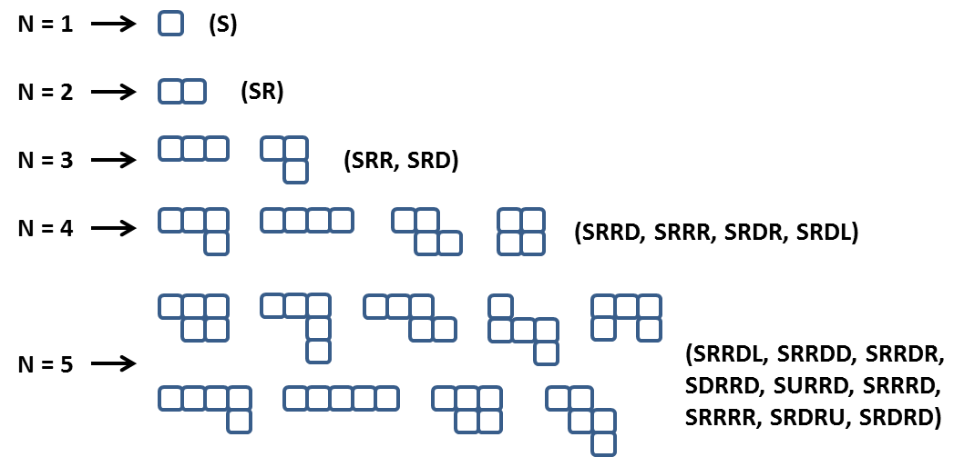

Note: some figures could look visually the same but represent different snakes, e.g. **SRRDL** and **SRDRU**.

Some snakes (sequences of blocks) are the same and should be printed only once. If after a number of rotations and/or flips two snakes are equal they are considered the same and should be printed only once. For example the snakes **SRRD**, **SRRU**, **SLLD, SLLU**, **SRUU** and **SUUR** are the same:



Not all forms consisting of N blocks are snakes of size N. Examples of non-snake forms:



**Note: When generating the snakes, there may be different correct answers. When testing your solution, priority should be as follows: R -> D -> L -> U. The visual example above for n = 5 does NOT follow this priority.**

### Input

* The input should be read from the console.
* It will contain an integer number **N** in the range [1 ... 15].
* The input data will always be valid and in the format described. There is no need to check it explicitly.

### Output

* The output should be printed on the console. It should consist of a variable number of lines:
* Each line should hold a snake represented as a sequence of moves.
* On the last line, print the number of snakes in format: **"Snakes count = {0}"**.

### Constraints

* Allowed working time for your program: 10 seconds. Allowed memory: 512 MB.

### Examples

|  |  |  |
| --- | --- | --- |
| **Input** | **Sample Output** | **Comments** |
| 2 | SR  Snakes count = 1 | Note that **SU**, **SL** and **SD** are also correct outputs. However, SR takes precedence because R has priority over all other directions. |
| 4 | SRRR  SRRD  SRDR  SRDL  Snakes count = 4 | Note that there are many other correct outputs for N = 4, but this is the expected output according to the priority of directions (right, down, left, up). |